HUDSON VALLEY DRAFT HORSE ASSOCIATION
PLOW DAY
APRIL 25, 2020
10:00AM-4:00PM
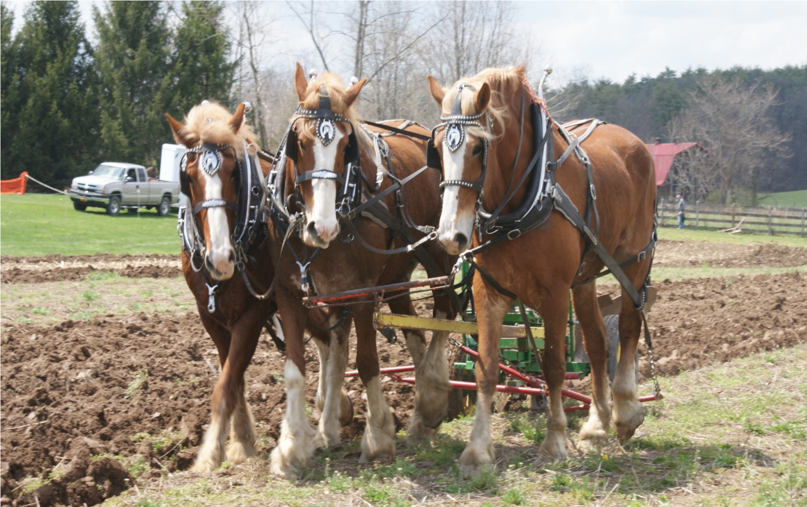

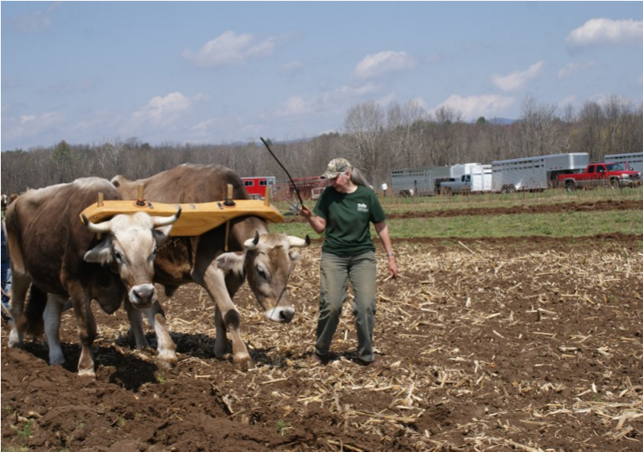

Featuring: Horses, Mules and Oxen
SAUNDERSKILL FARMS, 5100
RT. 209, ACCORD, N. Y. 12404
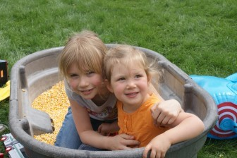
SPRING PLOW-APRIL 25, 2020
10AM-4PM $5.00 SUGGESTED
DONATION PER ADULT
INFO: 845 294-9016 or 845 657-2032
- Field plowing
- Wagon Rides
- Craft & Miscellaneous Vendors
- Country Demonstrations
- Live Music Ben Rounds and his band
- Good Food
- Kids games
- Oxen teams or working steers.
VENDOR FORMS: ROBIN 845 294-9016
E-MAIL: dmjure33@frontiernet.net
Vendor space 10x10 $35.00.

